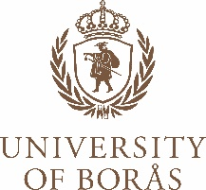

LETTER OF INTENT

This is to confirm that we, name of the company/organisation, will accept name of the student, a student of the University of Borås, Sweden, for a traineeship.

The placement will begin on YEAR-MONTH-DATE and finish on YEAR-MONTH-DATE.

Should the student be accepted for an Erasmus+* traineeship grant from the University of Borås, we agree to sign a Learning Agreement** with the student and the University of Borås.

Representative of the company/organisation

Name:
Title:
Phone number:
Email address:
Signature:
Date of signing:

*What is Erasmus+?
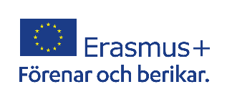
Erasmus+ is the EU's programme to support education, training, youth and sport in Europe. It has an estimated budget of €26.2 billion. The 2021-2027 programme places a strong focus on social inclusion, the green and digital transitions, and promoting young people’s participation in democratic life. It supports priorities and activities set out in the European Education Area, Digital Education Action Plan and the European Skills Agenda.

**Learning Agreement
All Erasmus+ trainees are required to have a Learning Agreement based on the Erasmus+ template before the start of the traineeship. The Learning Agreement is an agreement between the university, the receiving organisation and the student. It contains information on what the trainee’s main tasks will be as well expected learning outcomes and plans for monitoring and evaluation.
After the traineeship, the traineeship organisation needs to sign a certificate called Learning Agreement – after the mobility. This document is a summary of the student’s traineeship and also serves as a confirmation of stay.

Grant
Erasmus+ trainees receive a financial contribution from the Erasmus+ programme. The grant is financed by the EU and administrated by the sending university.

For more information about Erasmus+ visit https://erasmus-plus.ec.europa.eu/

